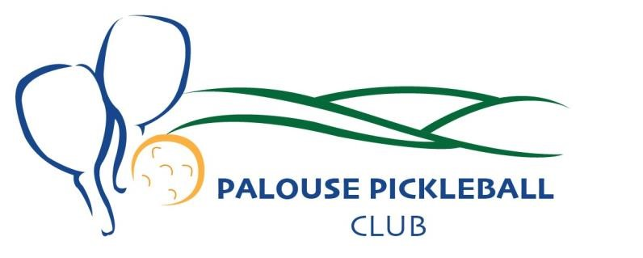

Palouse Pickleball Club Membership Form
Our goal as a non profit is to enhance the health and welfare of the general public by encouraging, organizing, and promoting participation in the sport of Pickleball within the City of Moscow, Idaho and the surrounding region

Last Name: __________________________________First Name: ______________________________ (PLEASE PRINT)
Mailing Address: ______________________________________________________________________

City/State/Zip: ________________________________________________________________________

Email Address: ______________________________________Phone: ____________________________ [ ] Check this box if you do not wish to receive club emails.

Emergency Contact Name: _______________________________Phone: _________________________

**Please provide any updates above, as needed, to the membership committee**

Annual dues are $20.00 per person per fiscal year,
January 1 to December 31 and will not be prorated for a partial year.
(We gladly accept and appreciate donations at any time to our non profit.)

Dues Amount Enclosed: $___________________

Agreement, Release & Waiver of Liability:
I recognize and understand that there are certain inherent risks to which I will be exposed because of the nature and level of the sports activity in which I have agreed to participate. I understand and agree that the PPC, their agents and officials assume no responsibility for injury or illness that I, or any additional family members, may sustain as a result of my physical condition or our participation in any PPC events. I understand it is my responsibility to provide my own accident and health insurance coverage and that PPC, their agents and officials, do not provide any accident or health insurance for their participants or volunteers. I also give permission for the PPC to use or distribute, without limitation or obligation, any record of events which may include my voice or image. As evidenced by my signature, thereby, for my heirs, administrators and assigns, release, waive and hold harmless the PPC, their agents, and officials from any manner of claims or lawsuits that may result from my participation, or the participation of any additional family members, in this sport.

Signature: ___________________________________Date: ___________________

Mail or hand submit the form a payment to the Palouse Pickleball Club c/o:

Sally Greene
1640 Lorien Lane Moscow, Idaho 83843 sgreene@gold.uidaho.edu

